Lab 4: DHCP Configuration on a Layer 3 Switch

1. Scenario
A company has two departments, IT and Sales, operating on separate VLANs. Previously, client computers required manual IP configuration.
To simplify network administration, a Cisco Layer 3 switch (SL3) was configured as a DHCP server to automatically assign IP addresses and network settings to clients in each VLAN.
2. Scope
- Configure DHCP services on a Cisco Layer 3 switch.
- Create separate DHCP pools for VLAN10 and VLAN20.
- Configure excluded IP address ranges.
- Assign IP addresses, subnet masks, default gateways, and DNS servers automatically.
- Verify DHCP assignments and inter-VLAN connectivity.
3. Objectives
- Understand the Dynamic Host Configuration Protocol (DHCP).
- Configure multiple DHCP pools on a Layer 3 switch.
- Provide automatic IP configuration to clients in different VLANs.
- Verify DHCP leases and network connectivity.
- Develop practical network administration and troubleshooting skills.
4. Network Scheme
Department | VLAN | Network | Default Gateway
IT | VLAN10 | 10.1.10.0/24 | 10.1.10.1
Sales | VLAN20 | 10.1.20.0/24 | 10.1.20.1
The Layer 3 switch performs both DHCP server and inter-VLAN routing functions.
5. Configuration
Two DHCP pools were created:
- IT_POOL for VLAN10.
- SALE_POOL for VLAN20.
Reserved IP addresses from .1 to .10 in each subnet were excluded from DHCP allocation.
Each DHCP pool was configured with its corresponding network address, default gateway, and DNS server (8.8.8.8).
6. Verification and Testing
The following commands were used:
- show ip dhcp pool — Verify DHCP pool configuration.
- show ip dhcp binding — Verify assigned IP addresses and client identifiers.
- ipconfig /all — Verify client network configurations.
- ping — Test gateway reachability and inter-VLAN connectivity.
Both IT and Sales clients successfully obtained their IP configurations through DHCP.
Connectivity tests confirmed successful communication with their respective gateways, the opposite VLAN gateway, and PCs in the opposite VLAN.

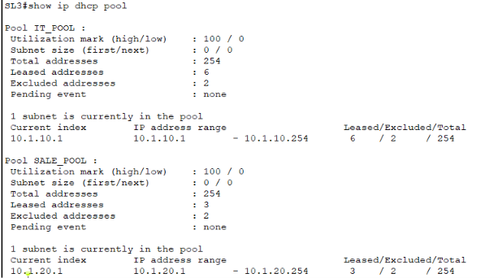

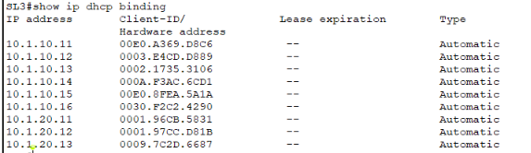
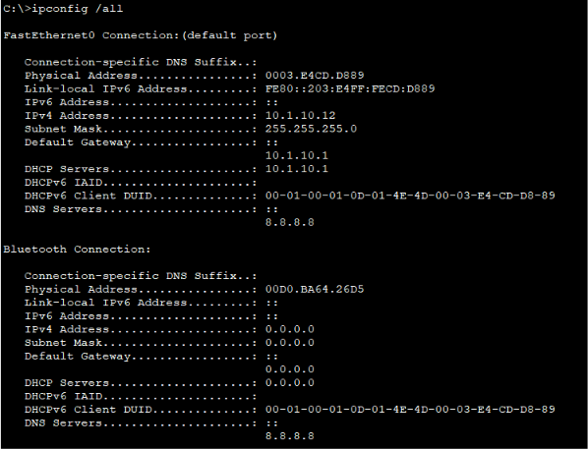
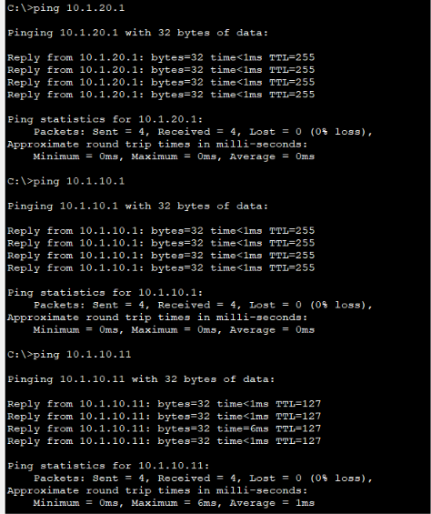
7. Summary
Successfully configured a Cisco Layer 3 switch as a DHCP server for two separate VLANs. Client devices automatically received the correct IP addresses, subnet masks, default gateways, and DNS server settings.
Connectivity testing confirmed that DHCP assignment and inter-VLAN routing were functioning correctly. This lab provided practical experience in DHCP configuration, IP address management, VLAN segmentation, and network troubleshooting.

